Lab Assignment 9

D. VIDHU SREE
2303A52400
BATCH 41
TASK : AI-Assisted Bug Detection
PROMPT: debug the error in the file and explain why it occurs
CODE:
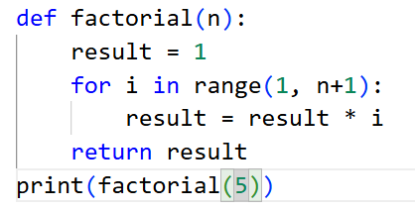
OUTPUT:
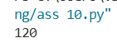
JUSTIFICATION:
Reason why error occurred : The range(1, n) generates numbers from 1 to n-1 (the upper limit is exclusive), so it skips n itself. For factorial(5), it only multiplies 1 × 2 × 3 × 4 = 24 instead of 5 × 4 × 3 × 2 × 1 = 120.
The code given by AI and the manually corrected code, both are same.
In this code we can clearly see that the code generated by AI is missing the edge case, when we give input as negative number, the expected output is not defined but we are getting 1, which is not correct.
TASK 02: Improving Readability & Documentation
PROMPT:
Complete the code and increase the readability by adding docstrings and also handle edge cases
CODE:
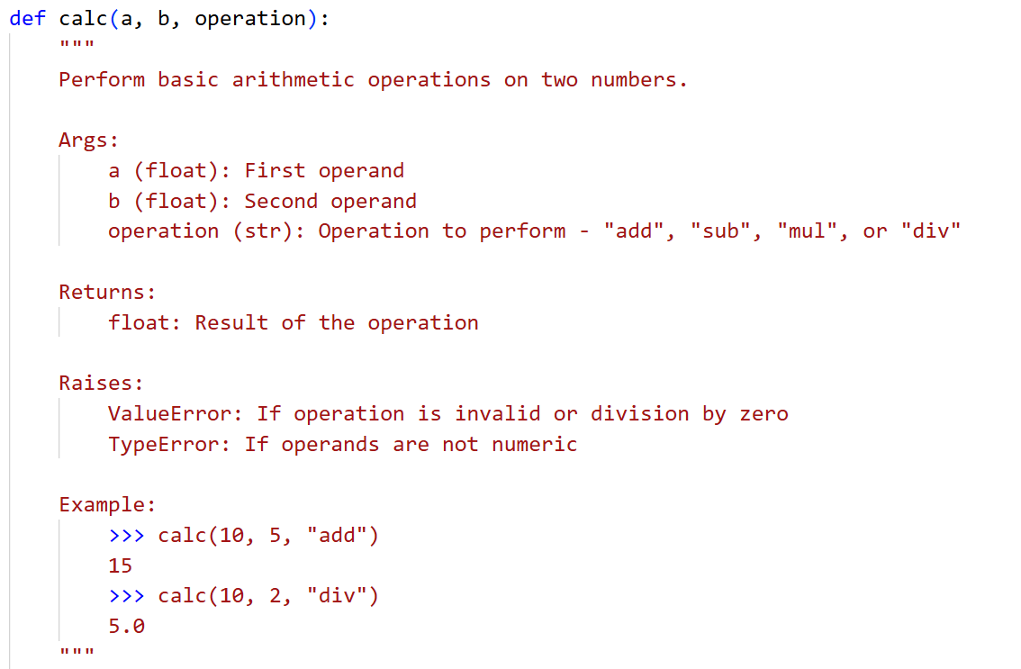
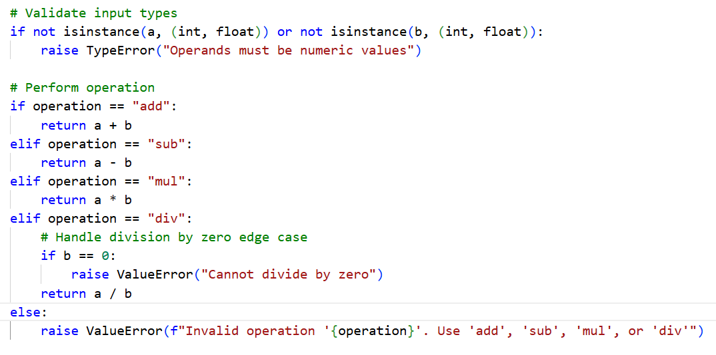
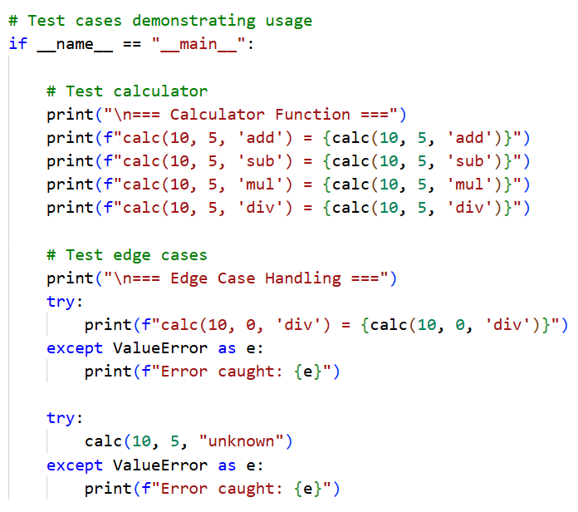
OUTPUT:
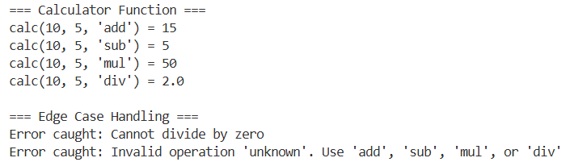
JUSTIFICATION:
In this task, we have finished the incomplete code given with the help of AI. With the help of A.I. we have added the required docstrings which helps in increasing the readability of the code.
The code given is incomplete code where as the code given by AI is fully completed.
In the corrected code given by AI, it is handling the edge cases like dividing by zero, giving invalid inputs like strings in place of numbers of giving number in place of operation. All these kind of invalid inputs and edge cases are handled well.
Testing of both valid and invalid inputs are done and they are handled well.

TASK 03: Enforcing Coding Standards
PROMPT:
Refactor the given code. If any changes needed perform them and verify.
CODE:
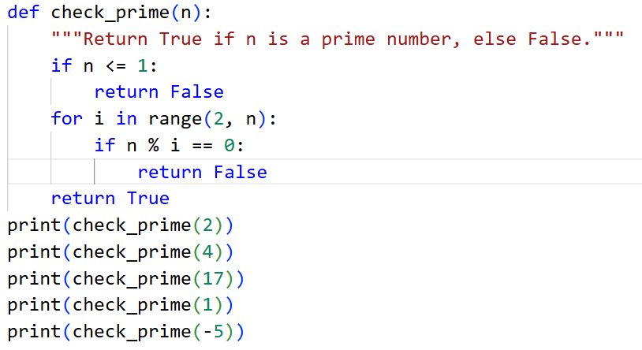
OUTPUT:
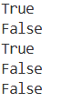
JUSTIFICATION:
PEP8 Violations :
- Function name not in snake_case → Checkprime should be check_prime
- Missing blank line before function definition
- No docstring provided
- Edge case not handled (n <= 1)
Automated AI reviews help large teams by instantly detecting coding standard violations, logical errors, and formatting issues. This reduces manual review time and ensures consistent code quality across the project. As a result, developers can focus more on improving functionality and system design rather than fixing minor style issues.
TASK 04 : AI as a Code Reviewer in Real Projects
PROMPT:
Refactor and improve the code in file by renaming for clarity purposes, and suggest generalization.
CODE:
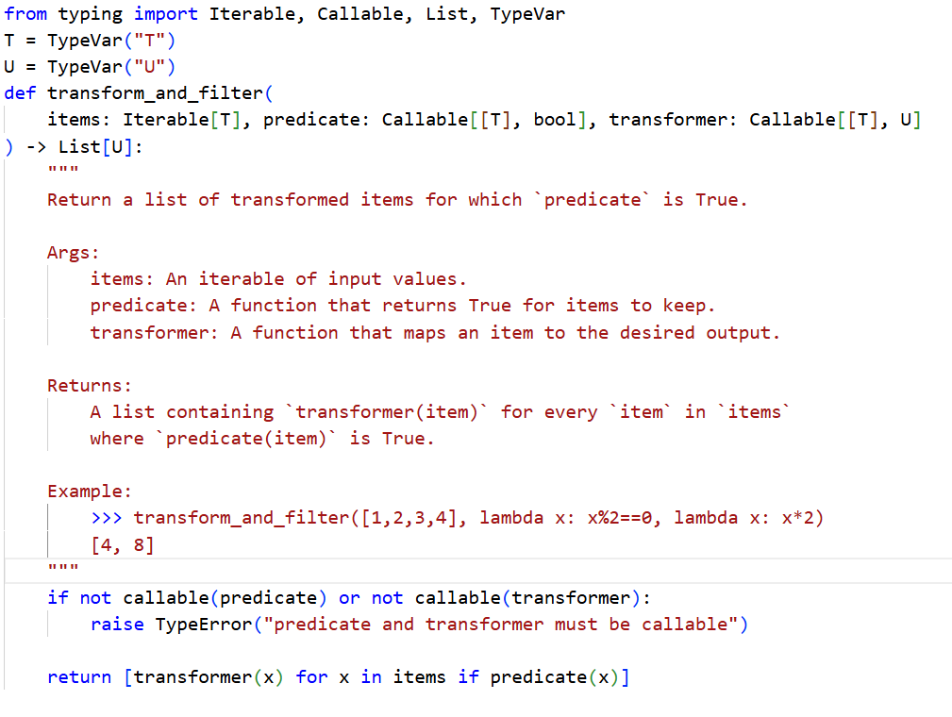
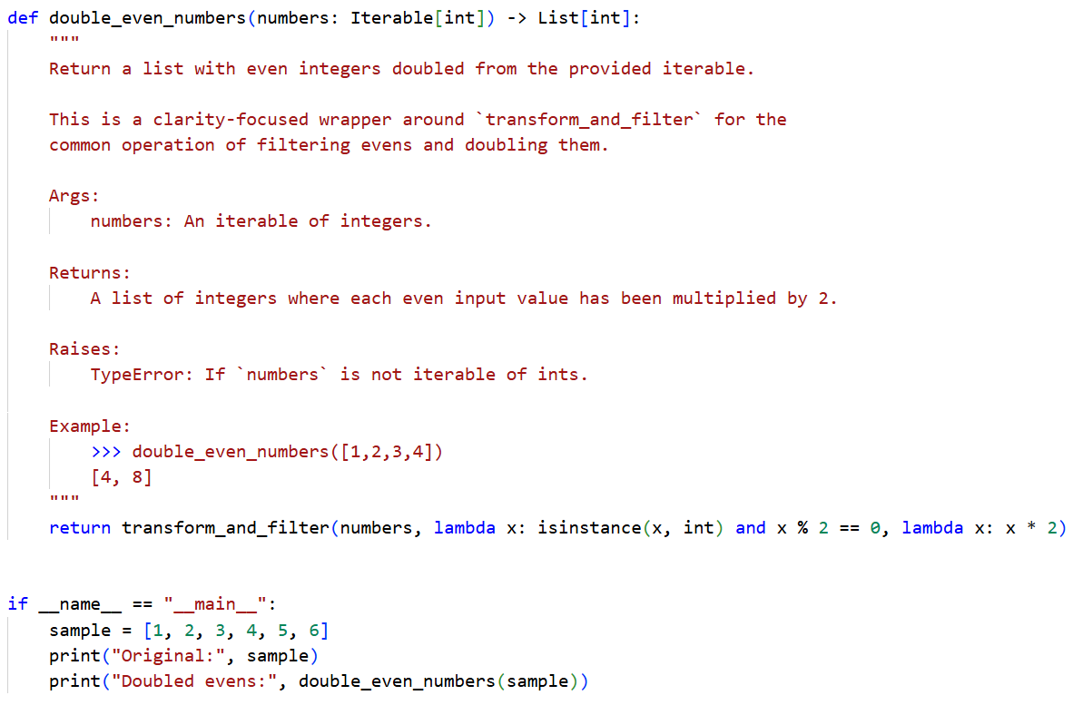
OUTPUT:
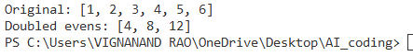
JUSTIFICATION:
Suggestions for generalization:
- Accept a max_items parameter for streaming/large iterables.
- Return an iterator (use yield) instead of a list for memory efficiency.
- Provide common predicates/transformers (e.g., is_even, scale_by(n)) in a small utilities module.
- Allow async predicates/transformers for IO-bound transforms.
AI should act as an assistant rather than a standalone reviewer. While it is efficient at detecting errors and enforcing standards, human reviewers provide critical thinking, context understanding, and design judgment. Combining AI speed with human insight leads to better and more reliable code reviews.
TASK 05: AI-Assisted Performance Optimization
PROMPT:
Analyze the given code, give time complexity, and then optimize the code and check for input range 1000000.
CODE:
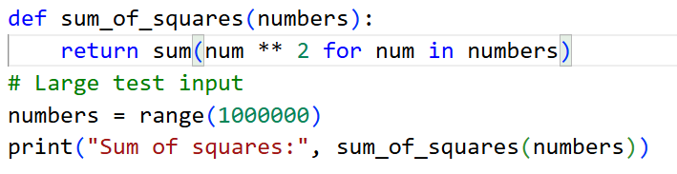
OUTPUT:
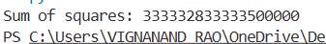
JUSTIFICATION:
Both the codes before and after optimization, it gives the same time complexity of O(n) as we must iterate till n number of times for getting the answer. We are optimizing the given code by using the in-built functions which helps to solve the problem easily.
Readable code helps humans understand, maintain, and debug programs easily. Highly optimized code may run faster but can become complex and harder to understand. So, it’s better to keep code simple and only optimize when performance is really needed.

